Sepi’s Email instruction upload:
- Modelkit Folder Tree as per https://github.com/sound-data/DEER-Prototypes-EnergyPlus?tab=readme-ov-file#prototype-models-generation-systemThe process is documented on GitHub with guides and training materials:
https://github.com/sound-data/DEER-Prototypes-EnergyPlus?tab=readme-ov-file#prototype-models-generation-system
Action items for Residential and Commercial Windows
- Upload files to GitHub and eTRM - Completed
- Add narrative justification to all file modification - Completed
- Provide content to measure characterization - Completed

Step 1 - Completed:
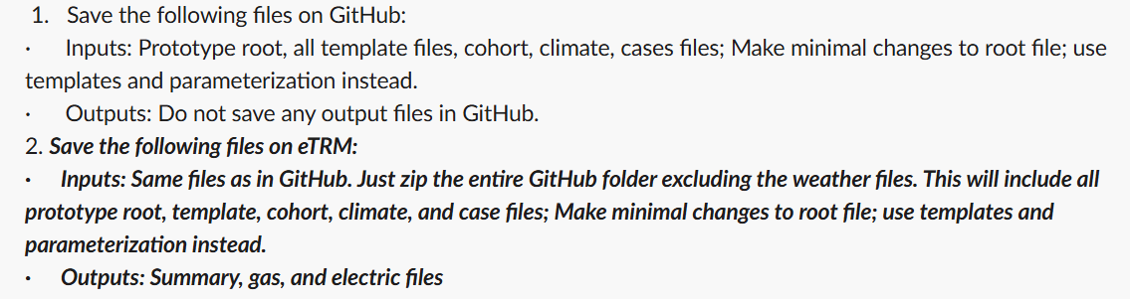

Step 2 Notes on files uploaded:
- DXGF DMo root file modified (to parametrize the windows)
- DEER_EnergyPlus_Modelkit_Measure_list_working.xlsx (only keep rows for modeled measures)
- DMo.py, SFm.py, MFm.py modified
- Python script to generate consolidated files to upload it to PostgreSQL.
- Python script to bypass the non-null to SizingID issue. Since this is envelope sizingID may not be required.
- Final files from step 5 uploaded to the PostgreSQL database after fixing duplicate TechID issue of MFm and DMo files and the timestamp issue.
- Impactprofile.SQL and all other 12 files were modified to the database I created. These files are referencing the MC_results_database

